SPECIFICATION

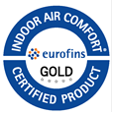
Quality : Sparta
Product definition : tufted loop pile
Gauge ISO 2424 : 1/10”
No. of tufts ISO 1763 : 173.360 /m² (- 7.5%. + 10%)
Pile fibre ISO 2424 : 100% PA SDN
Pile weight ISO 8543 : 510 gr/m² (± 5% )
Pile height ISO 1765 : 3.5 mm (± 5%)
Primary backing ISO 2424 : PA/PES non-woven - Colback
Tile backing ISO 2424 : Polyflex
Total thickness ISO 1765 : 5.2 mm (± 5%)
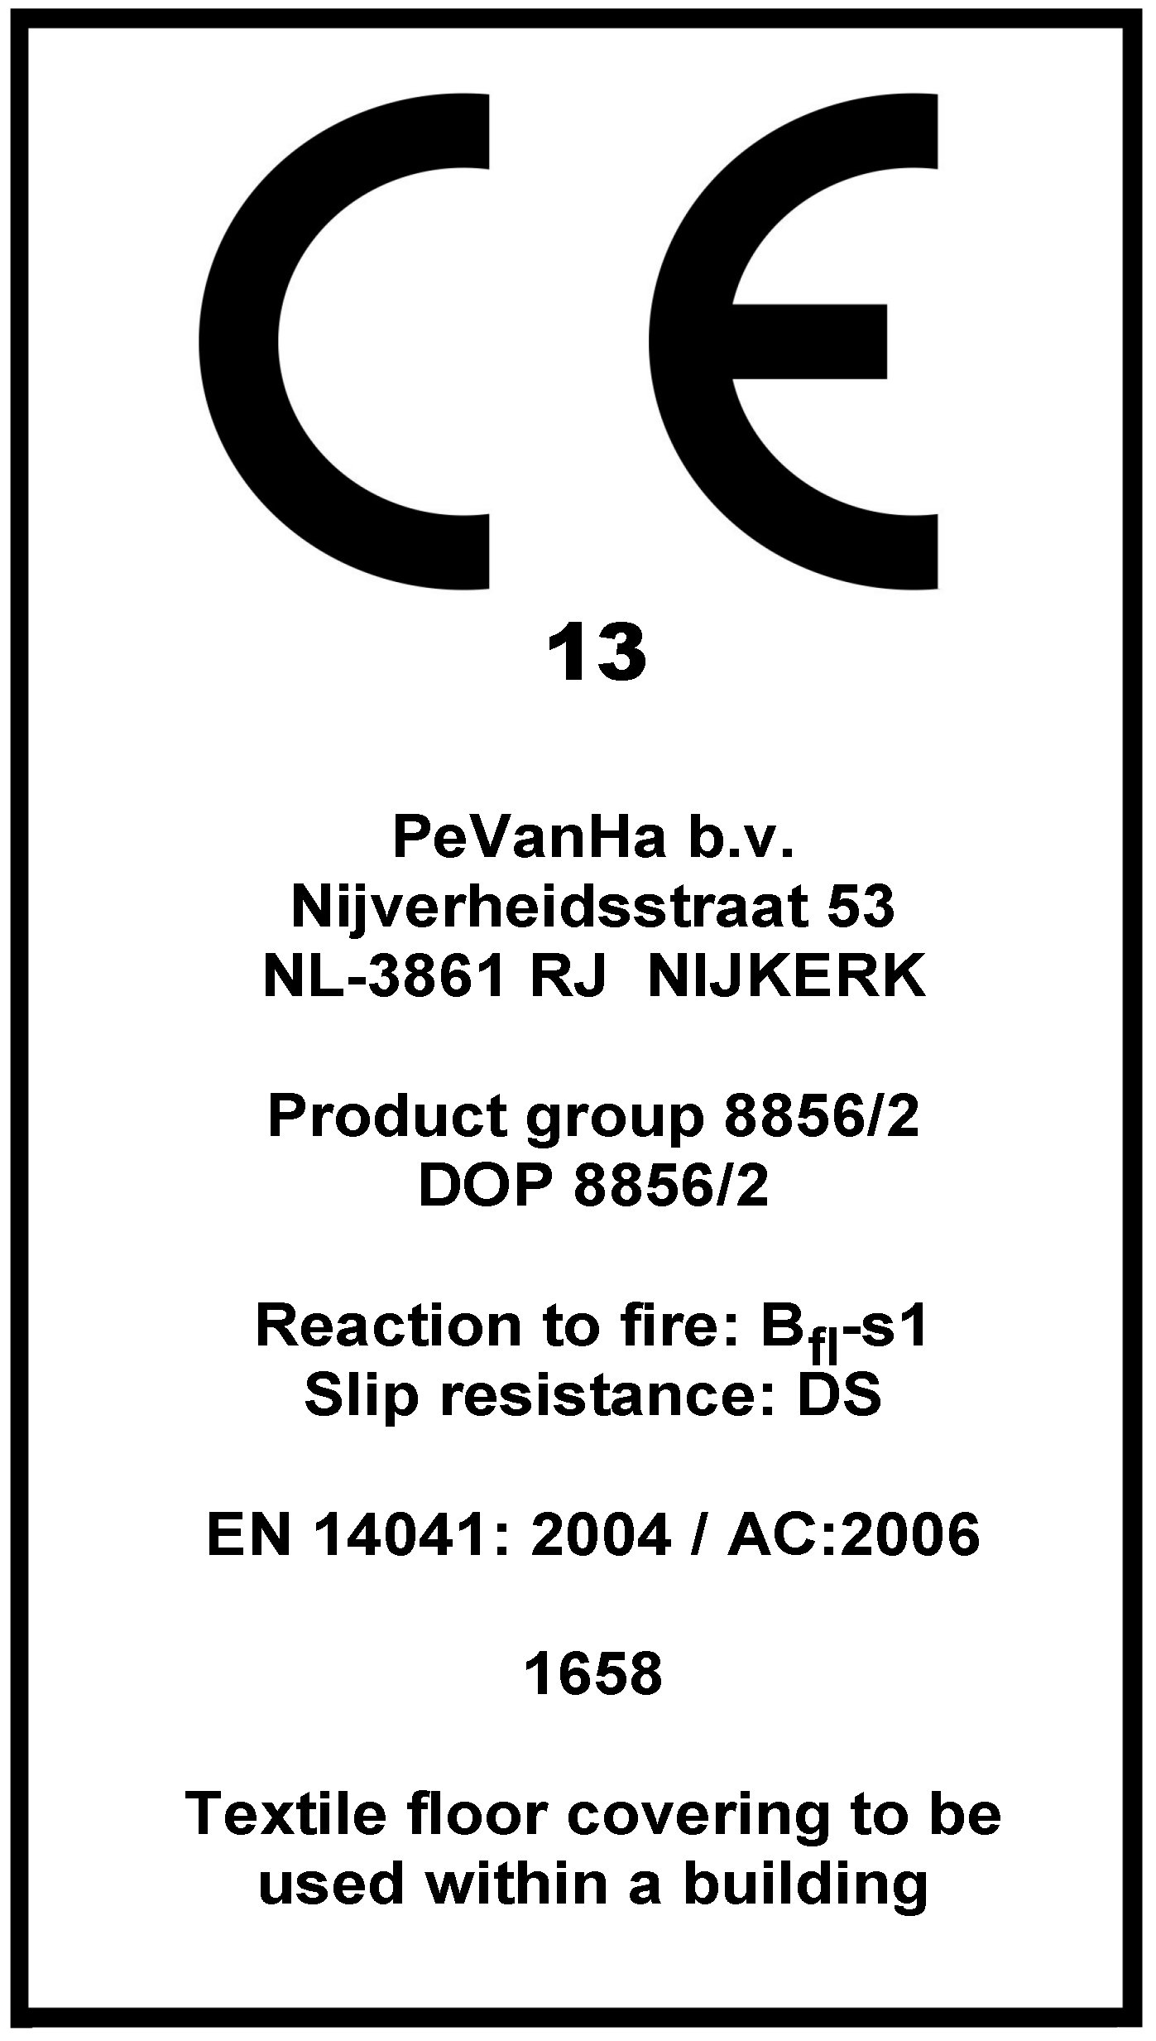
Total weight ISO 8543 : 3800 gr/m² ⁽± 7,5% )
Tile size EN 986 : 50 x 50 cm (± 0.2 %)
Tiles per box : 20

PERFORMANCE
Use classification EN 1307 : 33
Castor chair test EN 985 : A, continuous use
Thermal isolation ISO 8302 : Ca. 0,07 m² K/W
Luxery/Comfort EN 1307 : LC1
Sound Insulation ISO 10140 : 24 dB

ELECTROSTATIC PROPERTIES
Walk on test ISO 6356 : -0.1 kV
Horizontal electrical resistance ISO CD 10965 : 3x10⁸ Ω
Vertical electrical resistance ISO CD 10965 : 4x10¹⁰ Ω
Static loading : anti-static

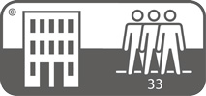




FLAME PROPERTIES

Reaction to fire EN 13501-1 : B_{fl} – s1




COLOUR FASTNESS PROPERTIES

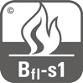
Light ISO 105 B02 : > 5



Rubbing, dry ISO 105 X12 : 5.0


Rubbing, wet ISO 105 X12 : 5.0
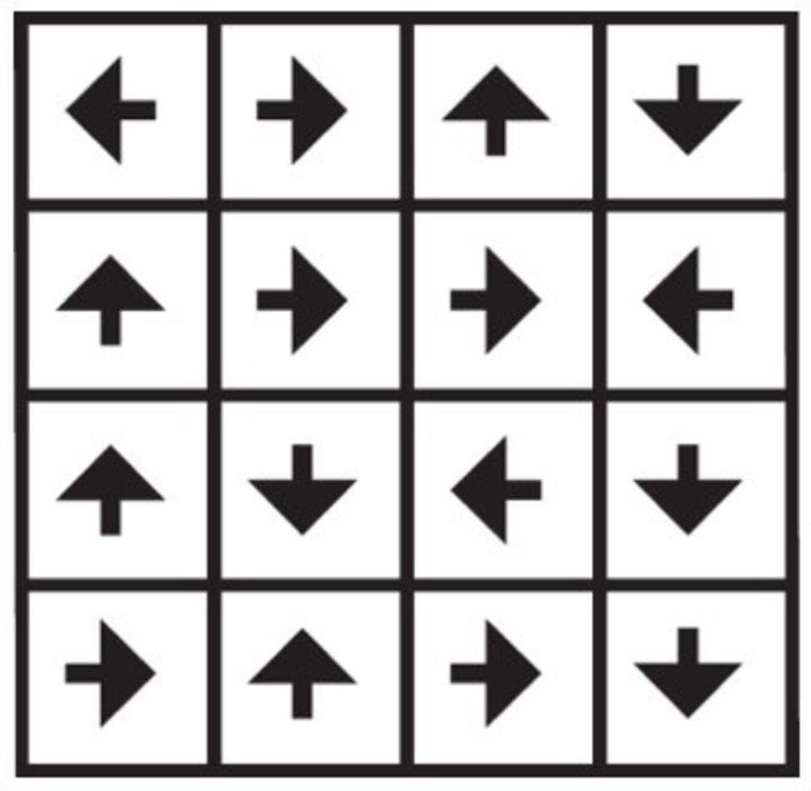
Shampoo BS 1006 : 5.0
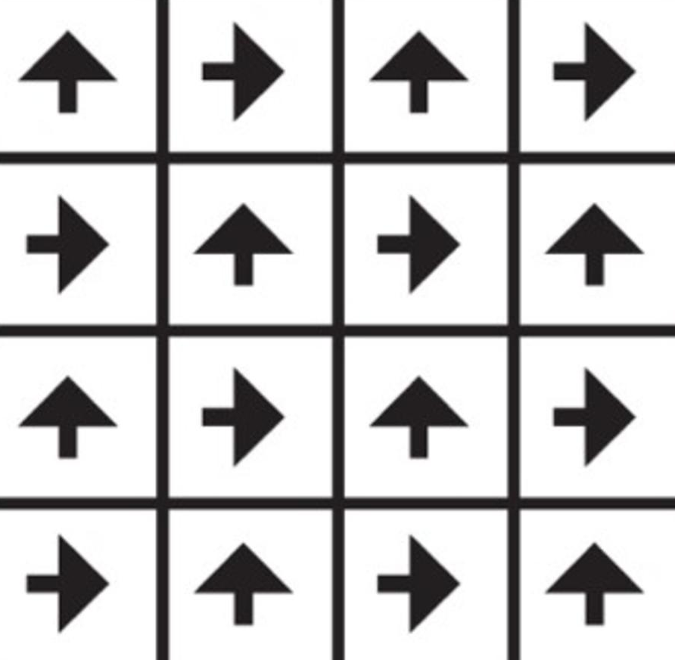
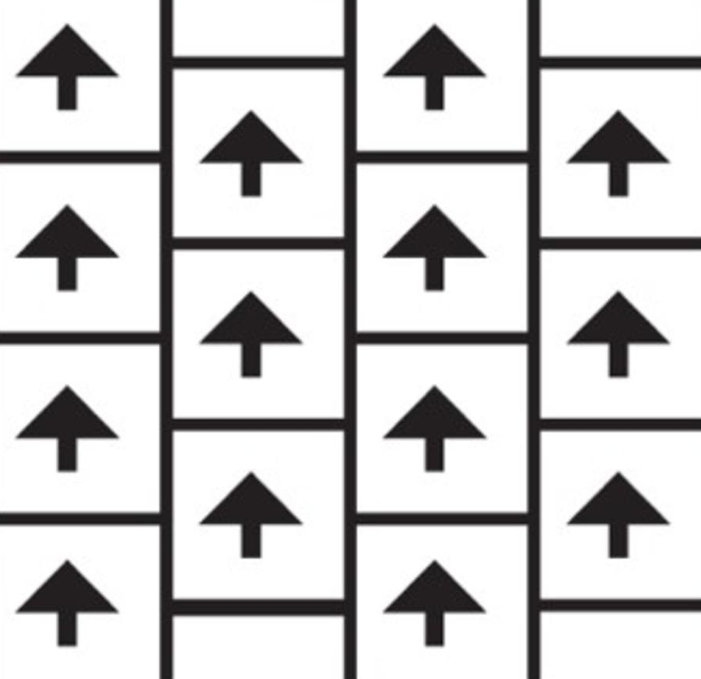
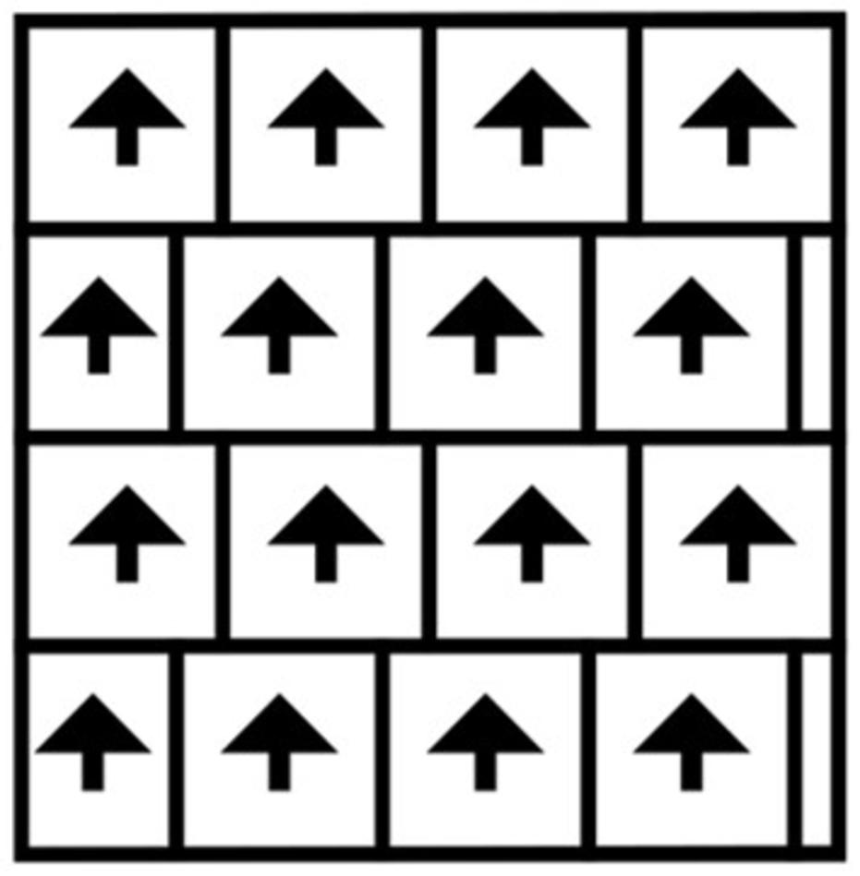
Water ISO 105 E01 : 4.5
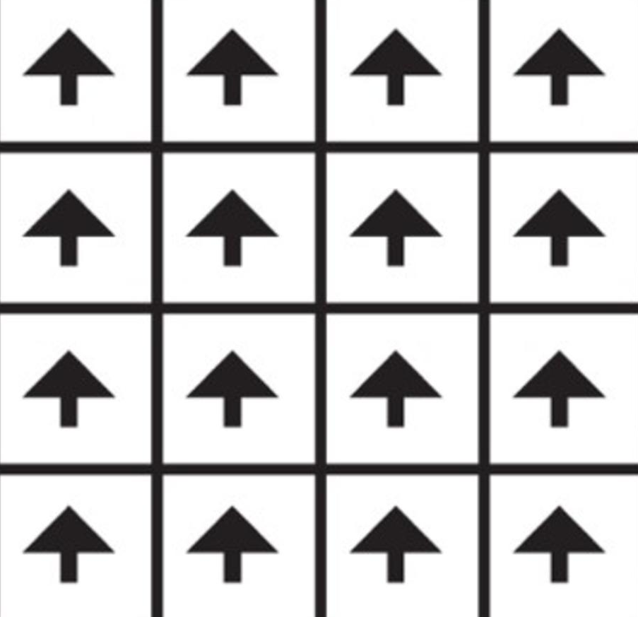
Water stains TNO W 6024 : 5.0

GENERAL

Recommended maintenance: Best results are obtained when cleaned with a dry shampoo method.
Pile direction: Directional arrows are printed on the back of each tile.
Best results are obtained when laid checkerboard.

Laying instructions: Tiles require no underlay, nailing, gluing or sewing and may be laid loose on a flat,
dry, non-slippery floor. When tiles are laid on parquet, vinyl or in open areas larger
than 30 m² it is advisable to use double sided adhesive tape on every 8th row or a
tackifier.
COLOURS

Col. 2778 |  |  | Col. 2777 | Col. 2772
Col. 2783 | Col. 2784 |  | Col. 2776 | Col. 2793
Col. 27278 |  |  | Polyflex  Backing | Felt  Backing

24.2.2023

