# 

# SPECIFICATION



Quality : **SKYPER**

Construction : Scroll loop pile

Dye method : Solution dyed

Gauge : Tufted 1/10”

No. of tufts ISO 1763 : ± 208820/m2

Pile fibre : 100% Nylon (PA 6)

Pile weight ISO 8543 : 550 gr/m2 ± 5%

Pile height ISO 1766 : 3.0 mm ± 5%

Primary backing : Non-Woven

Tile backing : Polyflex

Total thickness ISO 1765 : 5,8 mm ± 5%

Total weight ISO 8543 : 4100 gr/m2 ± 7,5%

Tile size : 50 x 50 cm (± 19.7” x 19.7”)

Tiles per box : 20

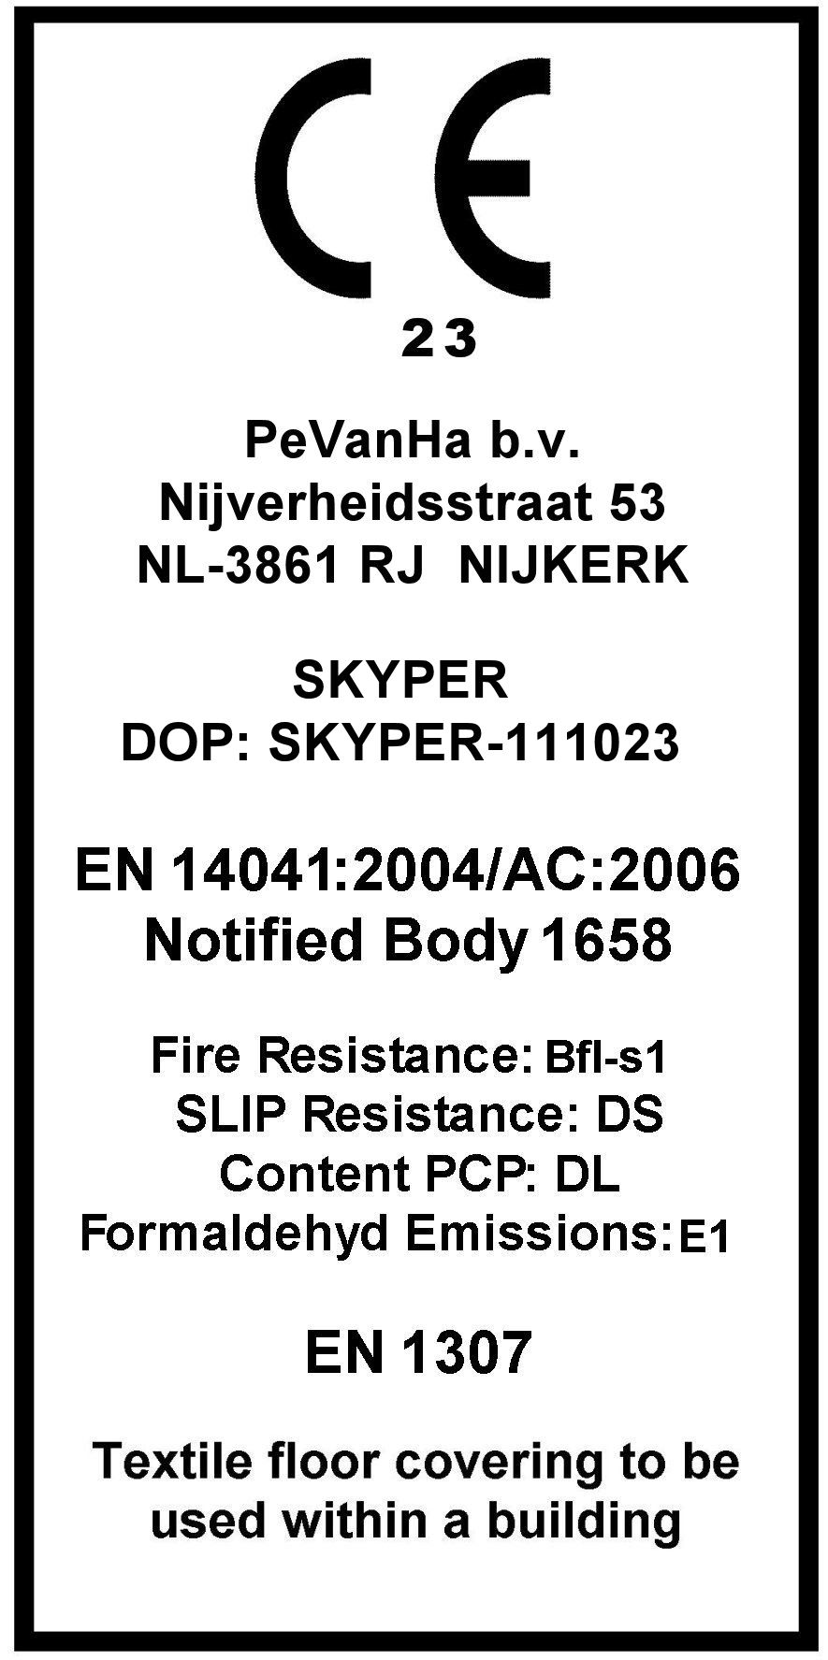

# PERFORMANCE

Use classification method en 1307 : 33

Castor chair test EN 985 / EN ISO 4918 : A - intensive use

Abrasion EN ISO 12951 : pass

Vettermann test ISO 10361: 2015 /

EN ISO 10833: 2019 : pass

Thermal resistance EN 12664 : R10 = 0,0666 m2 K/W

Thermal resistance EN 12664 : R23 = 0,0638 m2 K/W

Dimensional stability EN 986 : pass

Luxery/Comfort EN 1307 : LC1

Anti-slip property EN 16165 method B : R13

Impact sound insulation EN ISO 10140 : ΔLw = 23 Db

Sound Absorption EN ISO 354 : αw = 0.15 (H)

# ELECTROSTATIC PROPERTIES

Walk on test ISO 6356 : - 0,5 kV



Horizontal electrical resistance ISO 10965 : 4,2 x 10¹² Ω



Vertical electrical resistance ISO 10965 : 3,3 x 10¹¹ Ω

Static loading : anti-static

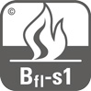

# FLAME PROPERTIES

Reaction to fire EN ISO 11925-2

EN ISO 9239-1 : Bfl – s1



# COLOUR FASTNESS PROPERTIES

Light EN ISO 105 B02 : 8

Rubbing, dry EN ISO 105 X12 : 5

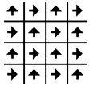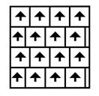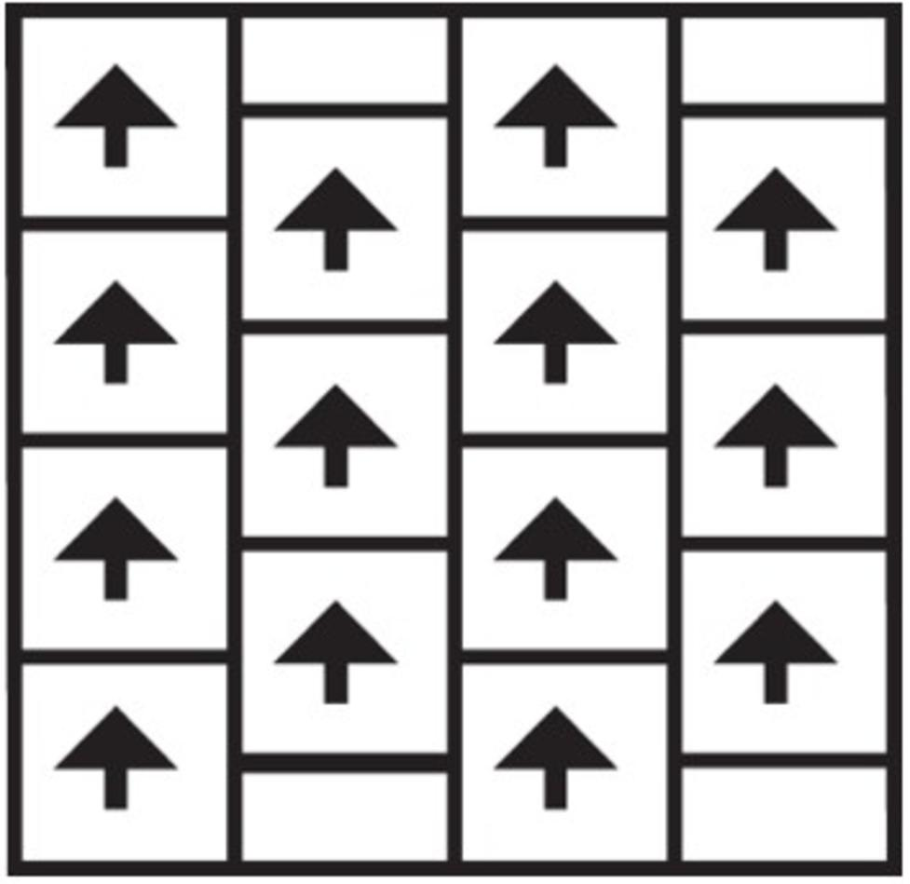

Rubbing, wet ISO 105 X12 : 5

Water, change in colour EN ISO 105-E01 : 4-5

# GENERAL

# Recommended maintenance: Best results are obtained when cleaned with a dry shampoo method.

Pile direction: Directional arrows are printed on the back of each tile.

Best results are obtained when laid quarter turn or brick.

Laying instructions: Tiles require no underlay, nailing, gluing or sewing and may be laid loose on a flat,

dry, non-slippery floor. When tiles are laid on parquet, vinyl or in open areas larger

than 30 m2 it is advisable to use double sided adhesive tape on every 8th row or a

tackifier.

**COLOURS**

|  |  |  |  |  |  |  |  |
| --- | --- | --- | --- | --- | --- | --- | --- |
| 6578 | |  | 6653 | 6558 |  | 6575 | 6545 |
| 6663 | 6633 | 6549 | 6544 |
| 6577 | 6576 |  |  |
| 6683 | 6574 | 6546 | 6547 |

21-08-2024